**Game Data API Documentation**

The Game Data API allows you to manage game-related information, including player statistics, game results, etc. The API is built using Node.js, Express.js, and MongoDB.

**Base URL:** [**http://localhost:3000/api/games**](http://localhost:3000/api/games)

Endpoints

**1. Create a new game entry**

Endpoint: POST /createGame

Request:

URL: /api/games/createGame

Method: POST

Request Body:

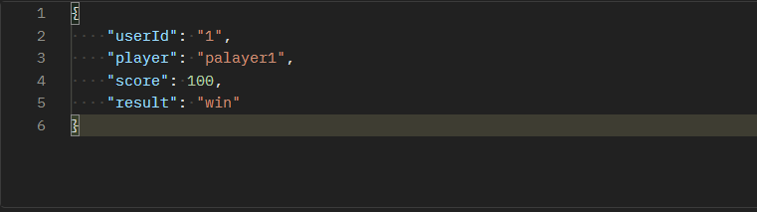

Response:

Status Code: 201 (Created)

Response Body:

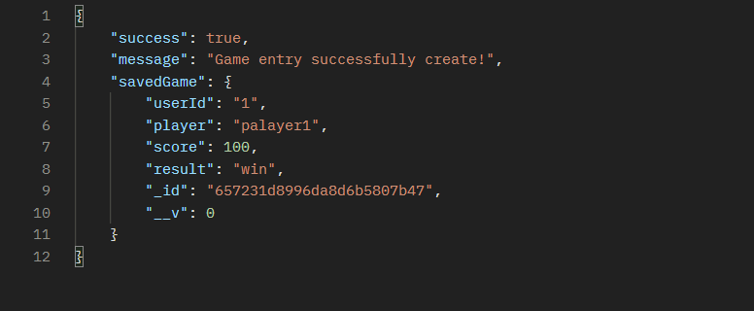

**2. Retrieve game data for a user**

Endpoint: GET /allGame

Request:

URL: /api/games/allGame

Method: GET

Response:

Status Code: 200 (OK)

Response Body:

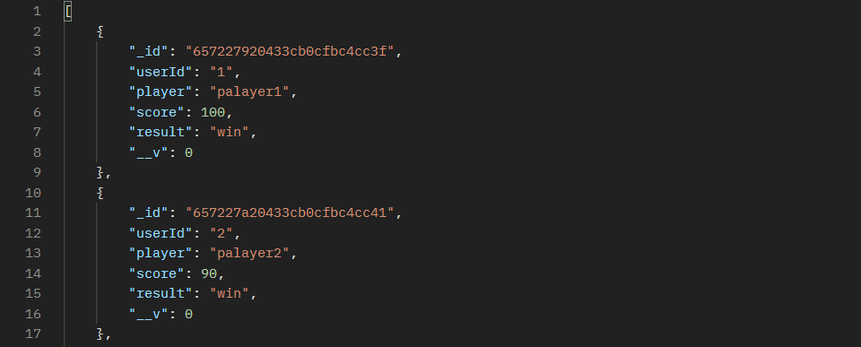

**3. Retrieve game data for a specific user**

Endpoint: GET /:userId

Request:

URL: /api/games/:userId

Method: GET

Response:

Status Code: 200 (OK)

Response Body:

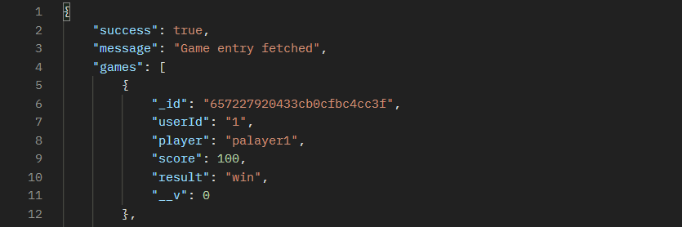

**4. Update game data for a specific user**

Endpoint: PUT /:userId

Request:

URL: /api/games/:userId

Method: PUT

Request Body:

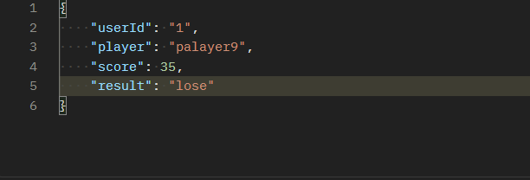

Response:

Status Code: 200 (OK)

Response Body:

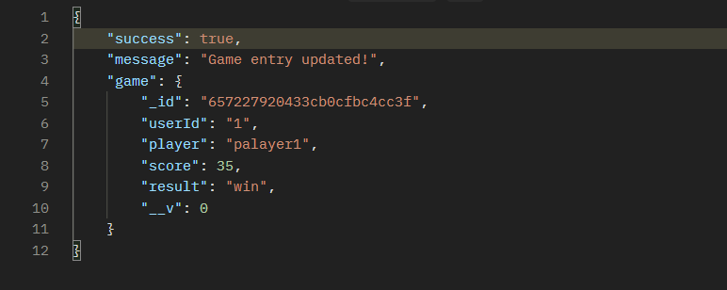

**5. Delete a game entry**

Endpoint: DELETE /:userId

Request:

URL: /api/games/:userId

Method: DELETE

Response:



Status Code: 204 (No Content)

And the entries have been saved in MongoDB compass:

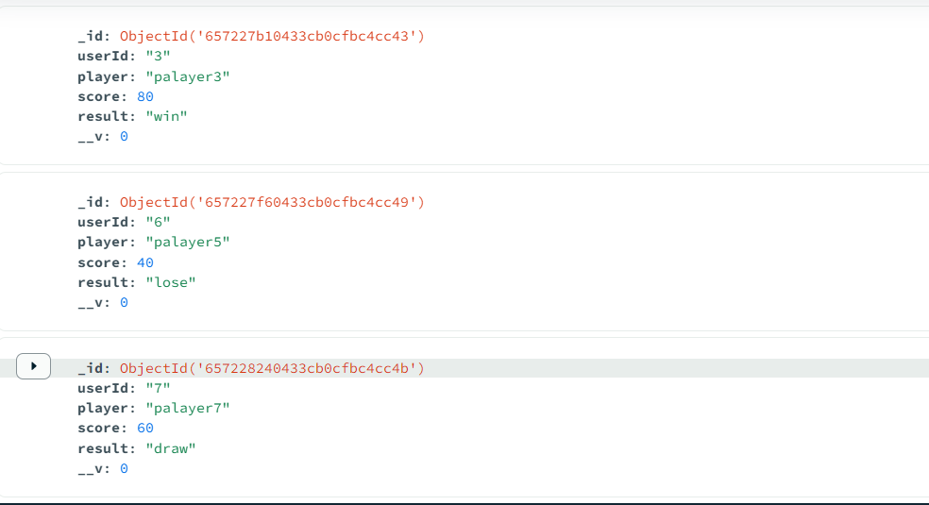

Conclusion:

This documentation provides an overview of the game data API, including CRUD operation i.e., create a game entry, update the game entry, get all game entries, get a specific entry, and lastly delete the game entry.